My repo is here: https://github.com/william215463497/Chen_project.git
Exercise
- Git clone
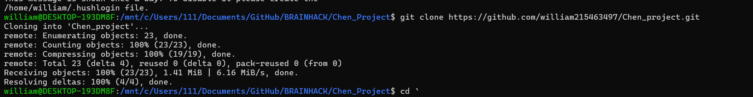

- Git push
(I pushed a new branch iss1)
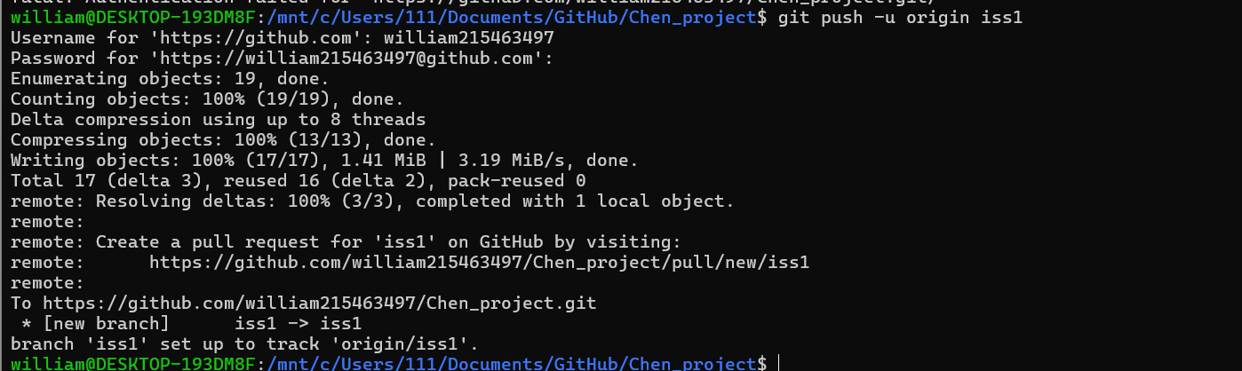

- New branch
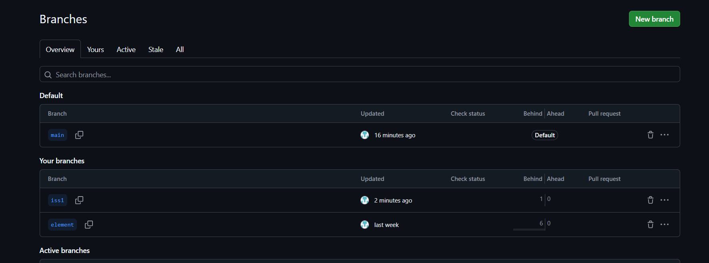

- Readme and License
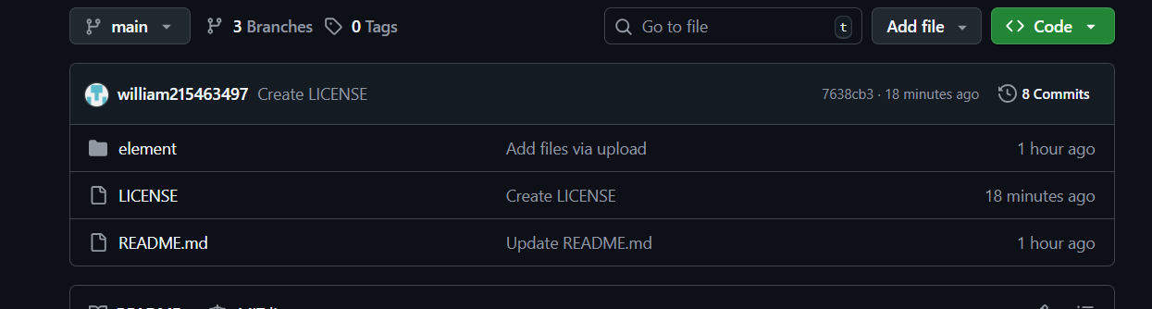

- self-introduction
